Project Design Phase-II

Data Flow Diagram &User Stories

|  |  |
| --- | --- |
| Date | 03October 2022 |
| Team ID | PNT2022TMID27503 |
| Project Name | Project – Smart solutions for Railways |
| Maximum Marks | 4 Marks |

**Data Flow Diagrams:**

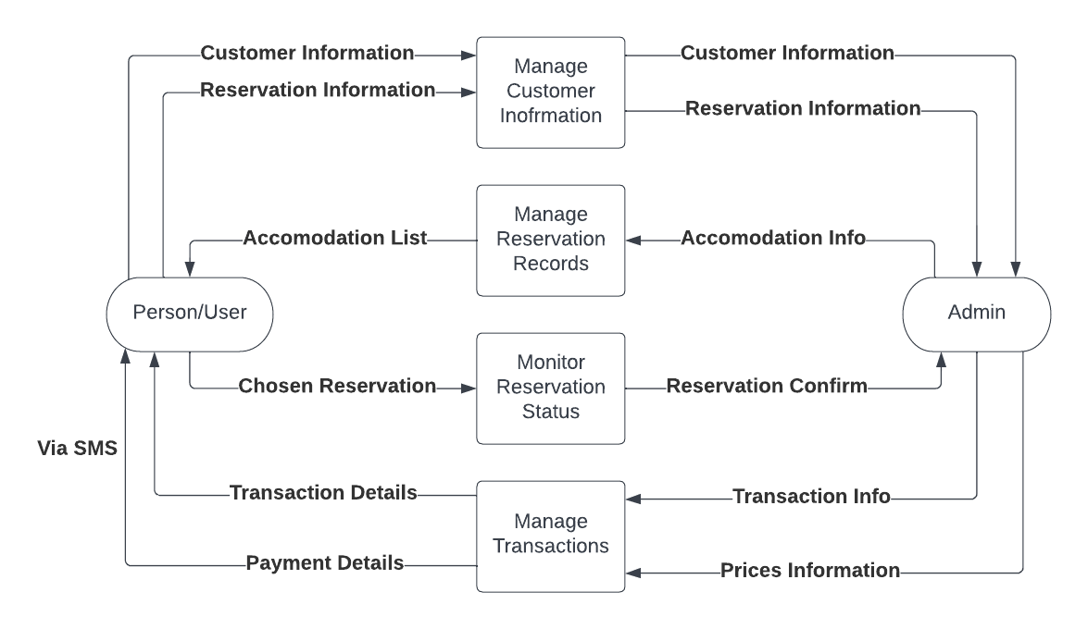

**User Stories**

Use the below template to list all the user stories for the product.

|  |  |  |  |  |  |  |
| --- | --- | --- | --- | --- | --- | --- |
| **User Type** | **Functional Requirement**  **(Epic)** | **User Story Number** | **User Story / Task** | **Acceptance criteria** | **Priority** | **Release** |
| Customer  (Mobile user, Web user) | Registration | USN-1 | As a user, I can register through the form by  Filling in my details | I can register and create my account / dashboard | High | Sprint-1 |
|  | Confirmation | USN-3 | As a user, I will receive confirmation through email or OTP once registration is successful | I can receive confirmation email & click confirm. | High | Sprint-1 |
|  | Authentication/Login | USN-4 | As a user, I can login via login id and  password or through OTP received on register phone number | I can login and access my account/dashboard | High | Sprint-1 |
|  | Display Train details | USN-5 | As a user, I can enter the start and destination to get the list of trains available connecting the above | I can view the train details  (name & number), corresponding routes it passes through based on the start and destination entered. | High | Sprint-1 |
|  | Booking | USN-6 | As a use, I can provide the basic details such as a name, age, gender etc… | I will view, modify or confirm the details enter. | High | Sprint-1 |
|  |  | USN-7 | As a user, I can choose the class, seat/berth.  If a preferred seat/berth isn’t available I can be allocated based on the availability. | I will view, modify or confirm the seat/class berth selected | High | Sprint-1 |
|  | Payment | USN-8 | As a user, I can choose to pay through credit  Card/debit card/UPI. | I can view the payment  Options available and select my desirable choice  To proceed with the payment | High | Sprint-1 |
|  |  | USN-9 | As a user, I will be redirected to the selected | I can pay through the payment portal and confirm the booking if | High | Sprint-1 |

|  |  |  |  |  |  |  |
| --- | --- | --- | --- | --- | --- | --- |
| **User Type** | **Functional**  **Requirement (Epic)** | **User Story Number** | **User Story / Task** | **Acceptance criteria** | **Priority** | **Release** |
|  |  |  | Payment gateway and upon  successful completion of payment I’ll be redirected to the booking website. | any changes need to be done  I can move back to the initial payment page |  |  |
|  | Ticket generation | USN-10 | As a user, I can download the generated  e-ticket for my journey along with the QR code which is used for authentication during  my journey. | I can show the generated QR code so that authentication can be done quickly. | High | Sprint-1 |
|  | Ticket status | USN-11 | As a user, I can see the status of my ticket  Whether it’s confirmed/waiting/RAC. | I can confidentially get the Information and arrange alternate transport transport if the ticket isn’t  Confirmed | High | Sprint-1 |
|  | Remainders notification | USN-12 | I get remainders about my journey  A day before my actual journey. | I can make sure that I don’t miss the journey because of the constant notifications. | Medium | Sprint-2 |
|  |  | USN-13 | I can track the train using GPS and can get information such as ETA,  Current stop and delay. | I can track the train and get to know about the delays pian accordingly | Medium | Sprint-2 |
|  | Ticket cancellation | USN-14 | User can cancel tickets if there’s any Change of plan | I can cancel the ticket and get a refund based on how close the date is to the journey. | High | Sprint-1 |
|  | Raise queries | USN-15 | User can raise queries through the query box or via mail. | I can view my pervious queries. | Low | Sprint-2 |